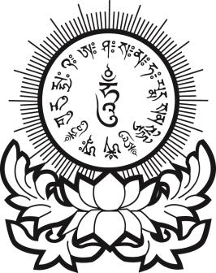
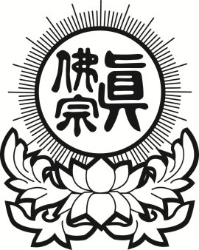
真佛宗紐約金剛雷藏寺
True Buddha Diamond Temple of NY
33-32 148th Street, Flushing, NY 11354
Tel: (718) 888-7919 Fax: (718) 888-1966

往生解冤資糧表格
（Rebirth, Resolving Grievances Supplies Registration Form）
祖先(亡者)姓名  （Name of Deceased） | 超度金紙  (Paper Money) | 超度冥幣  (Hell Money) | 超度蓮花  (Lotus Flower)
 | 份 | 份 | 朵
 | 份 | 份 | 朵
之近代祖先  (Ancestor) | 份 | 份 | 朵
之近代祖先  (Ancestor) | 份 | 份 | 朵
有意無意所傷害之眾生靈  (Intentionally killed or unintentionally killed sentient beings) | 份 | 份 | 朵
之冤親債主纏身靈  (Karmic Enemies & Attached Spirits) | 份 | 份 | 朵
之水子靈  (Attached Baby Spirits) | 份 | 份 | 朵
之福德正神、土地公、地基主  (Local Earth Deity) | 份 | 份 | 朵

陽居善信，一心至誠，虔誠供養，仰叩蓮生活佛、阿彌陀佛、觀音勢至、地藏慈尊、諸佛、菩薩，
靈光加庇，超度報名眾靈眾等，罪孽消除，悉獲超昇，往生極樂；俾陽居眾，安居樂業，生意興旺
事業昌隆，身體強健，如意吉祥，伏乞慈悲，虔誠是禱。

超度金紙 (Gold Money) 份 (Set x $ 5 ) ................ $
超度冥幣 (Netherworld Money) 份 (Set x $ 5 ) .................. $
超度蓮花 (Paper Lotus Flower) 朵 (Stem x $ 5) .................. $
………….................................................................
總金額贊助(Offering) $

支票抬頭(Check or Money Order Payable to) : True Buddha Diamond Temple of NY
主祈人姓名(Name Of Living Beneficiary)：
地址(Address)：

